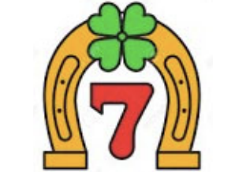

IT'S THAT TIME OF YEAR AGAIN!!
LUCKY “7” CLUB
$50 per ticket

Drawing: Sunday, December 17 at 12:45 p.m. in the Aquin Center

Don’t miss out on an opportunity to win CASH before Christmas!

Seven cash prizes will be awarded. Just return the form including your name, address, and phone number with your check to the parish office or drop it in the collection basket to reserve your ticket(s). It will be announced once tickets are available to be picked up.

Thank you in advance for your support and for working together to make the Parish Sweepstakes the most successful ever by selling out! May God bless you and your family for all that you do to make our parish a holy family.

LUCKY SEVEN SWEEPSTAKES

Name: ________________________________________

Phone Number: _________________________________

Address: ______________________________________

City: __________________________________________

Number of Tickets: _______________________________

Check # and Amount ______________________________

